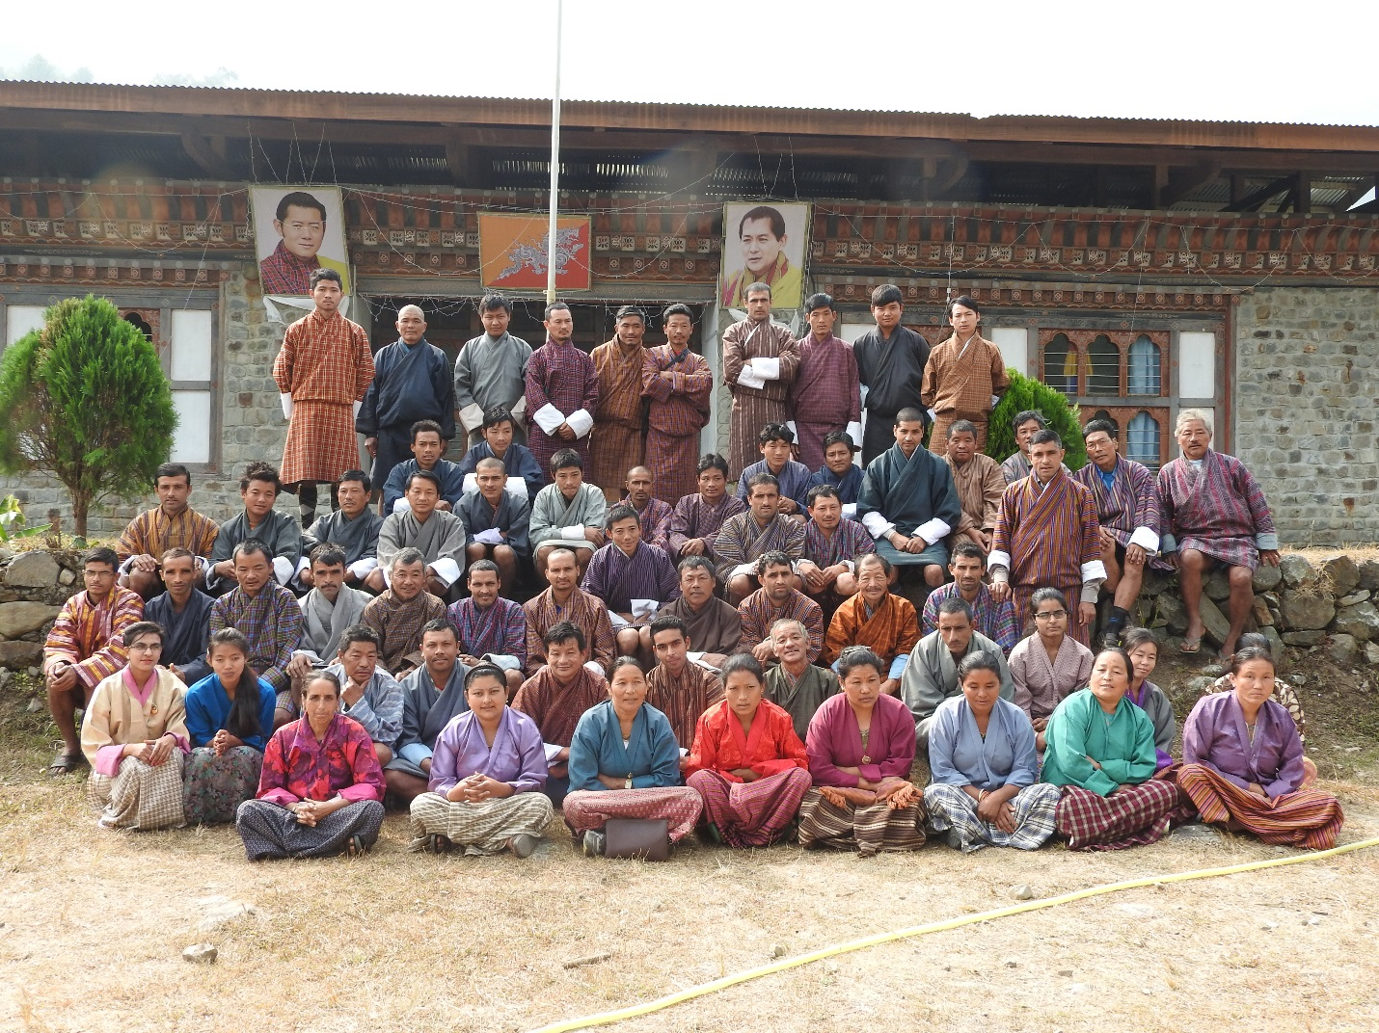
BUMPA SHINGMEN DULEN TSHOGPA MANAGEMENT PLAN, CHUDZOM GEWOG, SARPANG DZONGKHAG.

Plan Period: July 2022-June 2026

(2nd Revision)

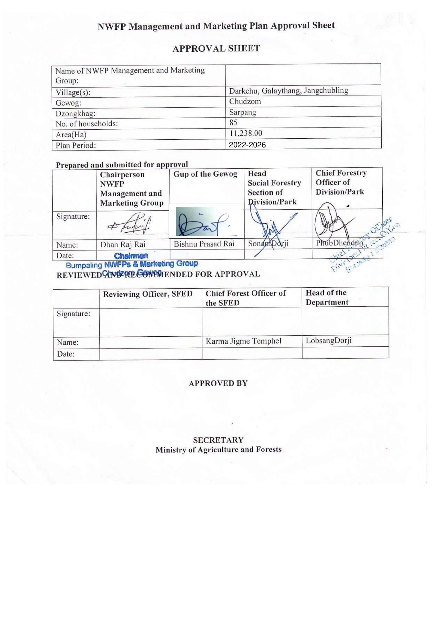

Table of contents
1. Back ground 1
2. Goal 2
3. General Objectives 2
4. Specific Objectives 2
5. Description of Non-wood Wood Forest Products 2
6. Harvesting prescription for sustainable NWFP harvesting. 5
7. Map o NWFPs collection area. 10
8. Marketing and sales plan 10
9. Marketing arrangements and Business Process 15
10.Benefits to the members 15
11. NWFP management & marketing group members 17
11.1 Responsibilities and rights of NWFPs Members: 17
12. NWFP management and marketing group management committee 17
12.1 Responsibilities of Coordinator/ Chairperson: 17
12.2 Responsibilities of Secretary: 18
12.3 Responsibilities of Treasurer: 18
13. Tenure of committee member 19
14. Incentives to the committee members 19
15. Membership Registration fee and annual contribution 19
15.1 New member 19
15.2 Resignation of members 19
16. NWFP group fund management and utilization 19
17. Conflict resolution 20
18. Meeting and purpose 20
19. Penalties 20
20. Power of the Department 21
Annexure I: Members of Bumpa Shingmen Dulen and Marketing Tshogpa, Chudzom Geog. 22

Part A: NWFP Resources Management and Marketing Plan

1. Back ground
The Bumpa Shingmen Dulen Tshogpa is located in Chudzom gewog which lies in the northern part of Sarpang Dzongkhag. The gewog covers the total area of 222.26 sq km within the altitude range from 1400 m to 1850 m above sea level. It shares boundary with Trongsa in the north, Tsirang in the west, Jigmecholing gewog in the east and Dekiling gewog in the South. The gewog has 5 chiwogs with 629 households and has a total population of 4359 people. About 80% of the geographically area of gewog is under forest cover and has rich vegetation and undisturbed ecosystem.
Out of 629 five chewogs in the Gewog, Bumpa Shingmen Dulen Tshogpa was formed by three chewogs- Drakchu, Jangchubling and Galaythang. These chewogs come to the consensus of 2nd revision of the plan upon expiry of 1st revision on 31st December, 2020. However,the revision was delayed due to restriction of movement during the Covid-19 pandemic and budget constraints.
Bumpa Shingmen Dulen Tshogpa constituted by 85 households from three Chiwogs. The total collection area of Non-wood Wood Forest Products (NWFPs) is 28,643 acres (11,238) of State Reserve Forest Land. It is inclusive of Private Registered Land of the members of Bumpa Shingmen Dulen Tshogpa.The following are boundary name of Bumpa Shingmen NWFPs area under Chudzom gewog.
Boundary No | Name | Latitude | Longitude
1 | Thotni khola | 27° 1'37.16"N | 90°22'4.51"E
2 | Deveni Dhap Seer | 27° 0'10.67"N | 90°19'22.75"E
3 | Deosari | 27° 0'39.80"N | 90°18'10.92"E
4 | Moukhola Seer | 27° 1'1.99"N | 90°17'0.90"E
5 | Pipali Dangra | 27° 1'46.46"N | 90°16'26.31"E
6 | Negali Dangra | 27° 3'14.47"N | 90°16'6.71"E
7 | Khali Dangra | 27° 5'57.70"N | 90°16'51.95"E
8 | Patibara Dangra | 27° 6'17.76"N | 90°21'10.18"E
9 | Opposite Lhayul | 27° 3'43.99"N | 90°22'46.86"E

Non-wood Wood Forest Products (NWFPs) like Swertia chiraita (Chirata), Thysanolaena latifolia (Kucho), Litsea cubeba (Siltimbur), Rubia cordifolia (Majeto), Acorus calamus (Bojho), Piper longum (Pipla), Paris Polyphylla (Satuva), Entanda rheedii (Pangra), Pouzolzia spp (Chipley), Calamus erectus (Patsha), Persea fructifera (Guli), Tupistra nutans (Nakima), Diplazium esculentum (Fern), Musa spp (Banana glossom), Nasturtium officianale (Tsim Sag) are NWFPs species identified for collection during the 2nd revision of Bumpa Shingmen Dulen Tshogpa Management plan . Refer table 01 for detail list of NWFPs for collection and quantity of each species estimated to be collected.

2. Goal
Enhance the social livelihood of the group through sustainable harvesting and marketing of Non-Wood Forest Products.

3. General Objectives
The forming of NWFP group is to establish sustainable utilization and management of Non-Wood Forest Products in their locality.

4. Specific Objectives
The specific objectives are as given below:
a. To enhance capacity of Bumpa Shingmen Dulen Tshogpa on sustainable harvesting and management of Non-wood Wood Forest Products (NWFPs).
b. To improve livelihood by selling Non-Wood Forest Products to the market and generate income of the NWPFs Group.
c. Ensure sustainable management and utilization of potential NWFP species and to generate income towards poverty alleviation.
d. To promote resources full utilization of downtrodden NWFPs freely available within the State Reserve Forest Land (SRFL).
e. To ensures balance development within the registered members without compromising the resources sustainability in long run.

5. Description of Non-wood Wood Forest Products
From the area identified for collection of NWFPs total of 19 species will be collected by Bumpa Shingmen Dulen Tshogpa for sale in domestic and export. The species are: Swertia chiraita (Chirata), Thysanolaena latifolia (Kucho), Rubia cordifolia (Majeto), Pouzolzia spp (Chipley), Piper longum (Pipla), Paris Polyphylla (Satuva), Viscum articulatum(Harchur), Plectocomia himalayana (Patsa), Banana blossom, Persea fruictifera (Guli), Tupistra nutans (Nakima), Nasturtium officianale (Tsim Sag), Diplazium esculentum (Fern), Litsea cubeba (Siltimbur), Mushroom (Shamu), Zanthoxylem bungeanum(Timbur), Entanda rheedii (Pangra), Acorus calamus (Bojho), Borinda grossa (Malingo). The part of plants and quantity to be collected commercial purpose in a year is shown in table 01.

Table 1: Brief description of Non-wood Wood Forest Products for commercial harvesting.
NWFPs Species | Harvesting area  (Name) | Parts harvested | Use purpose  (Traditional and others) | Harvesting season(months) | Estimate Quantity that can be collected in each season.
Swertia chiraita  (Chirata), | Torkey, Moukhola, Phedey | Entire Plant | Cures fever, cough | November-January | 100 Kg
Thysanolaena latifolia  (Kucho), | Terkola, Sukeykhola,  Torkey, Bichkhola, Jangchubling, Moukhola, Phedey | Inflorescences | Broom, fodder, | February- March | 2000 bundles
Rubia cordifolia (Majeto), | Terkola, Sukeykhola,  Torkey, Bichkhola, Jangchubling, Moukhola, Phedey | Stem | Dye | January- March | 500 Kgs
Pouzolzia sanguini  (Chipley) | Terkola, Sukeykhola,  Torkey, Bichkhola, Jangchubling, Moukhola, Phedey, Goongring | Bark | Adhesive, fodder, antiseptic, paste on wounds | November- March | 300 Kgs
Piper longum (Pipla), | Bagdangra, Tirkhola, Torkey | Fruits | Medicinal | December- January | 300 kgs
Paris Polyphylla  (Satuwa) | Deoni Daap, Jhandey, Bichkhola | Rhizome | Medicinal | November- December | 200 kgs
Plectocomia himalayana  (Patsha) | Terkola, Sukeykhola, Torkey, Bichkhola, Phedey, Goongring | Stem | Vegetable | February-  September | 1000 pcs
Dipazium esculentum  (Fern) | Jangchuling,  Darkchu, Galaythang | Leaves | Vegetable | April-  October | 3000 bundles
Mush room  (Shamu) | Jangchuling,  Darkchu, Galaythang | Fungi | Consumption | April-  December | 300 kgs
Banana Glossom | Jangchuling,  Darkchu, Galaythang | Glossom | Vegetable | April-  December | 500 nos
Zanthoxylum bungeanum  (Timbur) | Jangchuling,  Darkchu, Galaythang | Fruits | Spice | August-  September | 200 kgs
Viscum articulatum  (Harchur) | Jangchuling,  Darckchu, Galaythang | Climber | Medicine | September-  February | 20 kgs
Tupistra nutans  (Nakima) | Jangchuling,  Darkchu, Galaythang | Flower | Medicine | September-  October | 300 bundles
Rhus javanica  (Bakhimlo) | Jangchuling,  Darkchu, Galaythang | fruits | medicine | November-  December | 100 bottles
Persia fructifera  (Guli) | Jangchuling,  Darkchu, Galaythang | Fruits | Consumption | November-  December | 500 kgs
Dioscorea villosa  (Wild Yam) | Jangchuling,  Darkchu, Galaythang | Tuber | Edible | January-  March | 200 Kgs
Trachycarpus fortunei  (Thakroo) | Jangchuling,  Darkchu, Galaythang | Leaves | Broom | November-  February | 200 bundles
Borinda grossa  (Malingo) | Jandey, Dhap,  Noonpani,  Deorali Dangra | Bamboo | Ropes and mats | December- February | 200  bundles
Nasturtium officianale  (Tsim Sag) | Tirkhola, Bichekhola, Moukhola | Leaves | vegetable | All season | 3000 bundles
Docynia indica (Mel) | Jangchuling,  Darkchu, Galaythang | Fruits | Medicine | November-  December | 50 bottle

6. Harvesting prescription for sustainable NWFP harvesting.
The following harvesting prescriptions are indicated against each species based on the interim frame work for management and marketing of non-wood forest products, 2011and traditional harvesting techniques shared by the NWFPs group and village elders during the review of Management Plan.
Table 3: Harvesting prescriptions for sustainable harvesting
NWFP species | Harvesting prescriptions for sustainable harvesting
Swertia chiraita  (Chirata) | Collect only after commencement of seed dispersal  Harvest only after announcement by Coordinator or Gewog Forestry Officer usually after November.  Do not collect during February since there is risk of damaging the seed germination.
Thysanolaena latifolia  (Kucho), | Cut foliage, inflorescences with secateurs or sharp knife 15 cm above the ground.  Do not damage rhizome to induce good regeneration.  Light controlled fire is recommended to induce regeneration.
Rubia cordifolia (Majeto), | Use sharp scissors for the harvesting of the upper part of the plant.  Cut the plant at 5 cm above ground level.  Leave at least 10% of the plants without collecting or harvesting any raw materials from them (these plants shall act as seed plants for natural regeneration).  Do not collect roots.  Do not uproot entire plants
Pouzolzia spp  (Chipley) | Cut the plant above 10 cm above ground level so that it will coppice in the following year.  Do not damage young stands/seedlings/saplings by felling surrounding trees and poles.  Leave at least 10% of the plants to enhance natural regeneration.
Plectocomia himalayana (Patsa) | For mature stems  Cut cane stem only when mature, to be recognized by:  Loosening of leaf sheath from the lower part of the cane stem  Exposure of lowest part of the stem  Turning to yellow-reddish along the entire stem length  Diameter over the entire length of the cane is the same (the diameter at the lower part of the cane is reduced)  For cane shoots  Cut young shoot by bending the cane stem with the help of a long and strong stick with a hook  Do not cut the entire cane to collect the shoots  Cut the leading shoot with a sharp knife diagonally (not straight in order to avoid rotting of the remaining stump); leave lateral shoots  Care shall be taken to avoid damaging sucker buds (these will later develop into lateral shoots)  Guidelines for both mature stems and cane shoots  Uprooting, cutting of rhizomes / suckers shall be avoided.  Trees supporting the canes shall not be felled  The debris after harvesting canes should be taken outside the cane area in order to avoid infection with insect borers or fungi
Litsea cubeba  (Siltimbur) | Harvest fruit by handpicking or by lightly lopping of outer branches.  Do not cut down the tree for harvesting of fruit.  Harvest for domestic use only. It will be not used for commercial sale since group agreed to use only for domestic consumption only.
Piper longum (Pipla), | Collect fruits only when fully mature.  Harvest fruits only after the announced staring date for harvesting (Date is usually announced by the coordinator / Gewog Forestry In-charge generally in September).  Harvest fruits only by hand picking without damaging, cutting or uprooting the entire plant
Paris Polyphylla  (Satuva) | Harvest rootstock of matured satuwa that are more than 2.5 feet height and have produced more than 25 fruits.  Harvest rootstock only after seed dispersal usually in the month of November  Plant apart of rootstock with roots and upcoming sprouts back into the soil so that new growth shoots up as new plant.
Entanda rheedii (Pangra) | Collect fallen beans and harvest by using long bamboo sticks with hook.  Leave behind 20% of beans on the ground by covering with soil to promote regeneration.
Acorus calamus  (Bojho) | Vegetative propagation is the best completed in the fall or spring using firm healthy rhizomes cut into 2 to 4 inches sections.  The spadix will turn brown as the seeds ripens in late summer or early fall seeds can be planted immediately or stored in low humidity refrigerator.  Rhizomes should be harvested in early spring before new growth or late autumn when it is large after 2-3 years of growth before becoming hollow.  Usually its vegetative propagation is done from mid-February till mid-April.  Rhizomes are usually collected during autumn (September-October) till early spring March-April. It is not advisable to collect in the month of April-August during its flowering and fruiting season.  It will be exclusively used for domestic purpose.
Viscum articulatum  (Hurchur) | Do not cut down the host plant to ease collection.  Do not collect the whole bunch.  Leave at least 25% for flowering and fruiting.
Banana blossom | Matured banana blossom will be felled.  Only 2 -3 blossoms will be collected from one clump.  Should not damage banana saplings while felling banana plants.
Zanthoxylem bungeanum  (Timbur) | Harvest fruit by handpicking, if possible, climbing on trees.  Use long bamboo poles with a hook to facilitate picking of the fruit.  Collect only 70% of the fruits and leave 30% to allow natural regeneration.
Trachycarpus fortunei  (Thakroo) | Do not cut whole plant.  Cut matured branches and leave seeds for regeneration.  Retain immature branches
Tupista nutans  (Nakhima) | Collect only flowers by hand.  Do not uproot mother plants.  Do not expose plant root to direct sunlight
Persia fruictifera  (Guli) | Don’t cut down tree and branches for collection of fruits.  Collect fruits only from the ground.
Diplazium esculentum  (Fern) | Harvests young shoot that are 15cm length.  Don’t harvest all shoot coming up in season.  Retain at least 50% of young shoot of last flush for the development of leaves.  Don’t harvest the shoots that have developed to leaves
Borinda grossa  (Malingo) | Cut culm above first internode from the base.  Leave bamboo shoot or culm of less than one year old intact.  Cut at maximum 33% of the 1+ year and 2+ year old culm per clump.  Do not cut culm when new shoots are sprouting.

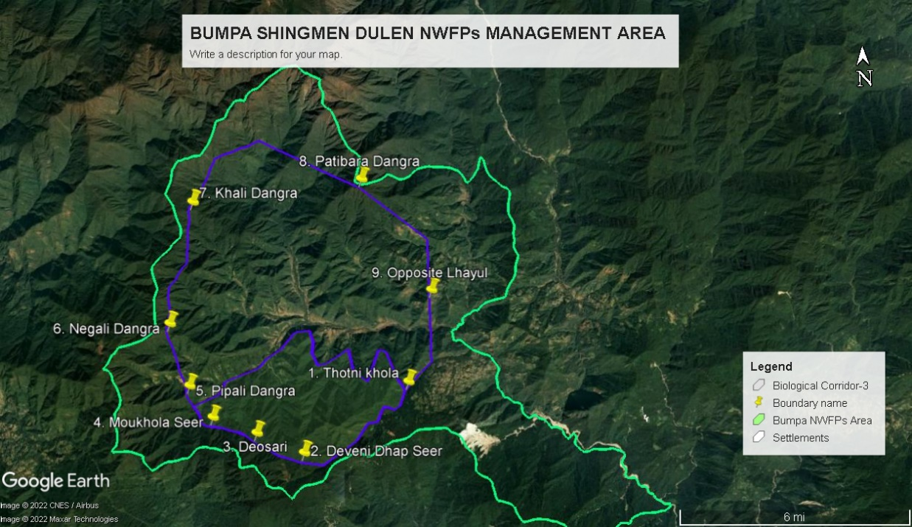
7. Map o NWFPs collection area.

8. Marketing and sales plan
The forest produces will be collected and marketed on annual basis depending on the demand and market availability. Refer table (------) for details of sale projection plan of the NWFP group. As per the marketing and sale plan, NWFP management group could earn sum of Nu.1713000/year and each household can earn an additional income of Nu.20152.94 in a year.
Table 4: Sale projection plan
Sl No | NWFP name | Potential market | Estimate quantity for sale per season (Unit) | Form of products (dry/fresh) | Expected per unit | Total (Nu)
1 | Swertia chiraita (Chirata), | Export | 100kg | dry | 85 | 8500.00
2 | Thysanolaena latifolia (Kucho), | Export | 2000 bundle | dry | 45 | 90,000.00
3 | Rubia cordifolia (Majeto), | Export | 500 kg | dry | 40 | 20,000.00
4 | Pouzolzia spp (Chipley) | Export | 500 kgs | dry | 45 | 22500.00
5 | Piper longum (Pipla), | Export | 300 kgs | dry | 150 | 45000.00
6 | Paris Polyphylla (Satuwa) | Export | 200 kgs | dry | 3500 | 700000.00
7 | Entanda rheedii (Pangra) | Domestic | 2000 kgs | dry | 15 | 30,000.00
8 | Litsea cubeba (Siltimbur) | Domestic | 300 kgs | fresh | 60 | 18000.00
9 | Acorus calamus (Bojho), | Domestic | 3000 kgs | dry | 100 | 300000.00
10 | Tupistra nutans (Nakima) | Domestic | 300bundles | fresh | 30 | 9000.00
11 | Calamus erectus (Patsha) | Domestic | 1000 pcs | fresh | 30 | 30000.00
12 | Dipazium esculentum (Fern) | Domestic | 3000 bundles | fresh | 25 | 75000.00
13 | Banana blossom | Domestic | 500 nos | fresh | 30 | 15000.00
14 | Nasturtium officianale (Simrai sag) | Domestic | 3000 nos | fresh | 25 | 75,000.00
15 | Docynia indica(Mel) | Domestic | 50 bottles | Fruits | 5500 | 275000.00
 | Total |  |  |  |  | 1713000.00

Table 5: NWFPs Sale Plan
16
Sl. No | Particulars | Products (names) refer to Table 4. |  |  |  |  |  |  |  |  |  |  |  |  |  |  | Total Amount (Nu)
 |  | 1 | 2 | 3 | 4 | 5 | 6 | 7 | 8 | 9 | 10 | 11 | 12 | 13 | 14 | 15
1 | Revenues
a | Total quantity (unit) | 100 | 2000 | 500 | 500 | 300 | 200 | 2000 | 300 | 3000 | 300 | 1000 | 3000 | 500 | 3000 | 50 | 16250-
b | Market price (Nu per unit) | 85 | 45 | 40 | 45 | 150 | 3500 | 15 | 60 | 100 | 300 | 30 | 25 | 30 | 25 | 5500 | -
c | Total revenues from forest product sales (a*b) | 8500 | 90000 | 20,000 | 22500 | 45000 | 700000 | 30000 | 18000 | 300000 | 9000 | 30000 | 75000 | 15000 | 75000 | 275,000 | 1713000.00
A | Total revenues | 8500 | 90000 | 20000 | 22500 | 45000 | 700000 | 30000 | 18000 | 300000 | 90000 | 30000 | 75000 | 15000 | 75000 | 275,000 | 1713000.00
2 | Expenses
a | Packaging materials | 1000 | 5000 | 2000 | 3000 | 1000 | 5000 | 1000 | 2000 | 5000 | 1000 | 1000 | 2500 | 1000 | 25000 | 5000 | 60500.00
b | Royalty | 2400 | 200 | 1000 | 12000 | 6000 | 3000 | 1000 | 1500 | 15000 | 2000 | 400 | 5000 | 2000 | 4000 | 2000 | 57500.00
c | Transportation costs | 1000 | 5000 | 3000 | 1000 | 1000 | 5000 | 2500 | 1500 | 7000 | 1500 | 3000 | 5000 | 3000 | 5000 | 3500 | 48000.00
d | Compensation fee to executive committee for marketing products (3%) | 255 | 2700 | 600 | 675 | 1350 | 21000 | 900 | 540 | 900 | 270 | 3000 | 2250 | 450 | 2250 | 8250 | 45390.00
e | Contribution to community development fund(10%) | 850 | 9000 | 2000 | 2200 | 4500 | 70000 | 3000 | 1800 | 3000 | 9000 | 3000 | 7500 | 1500 | 7500 | 27500 | 152350.00
f | Incidental expenses |  |  |  |  |  |  |  |  |  |  |  |  |  |  |  | 10000.00
B | Total expenses |  |  |  |  |  |  |  |  |  |  |  |  |  |  |  | 373740.00
C | Total benefit (net-income) of group members  (total revenues A – total expenses B) |  |  |  |  |  |  |  |  |  |  |  |  |  |  |  | 1339260
D | Average income to group members (C/ no of group members) |  |  |  |  |  |  |  |  |  |  |  |  |  |  |  | 15756.00
E | Price per unit paid to group members (C/1a) |  |  |  |  |  |  |  |  |  |  |  |  |  |  |  | 82.41

9. Marketing arrangements and Business Process
NWFP grown within the collection area of Bumpa Shingmen Dulen Tshogpa will harvested sustainably and marketed as business plan. As per the management plan, collection of NWFPs will done by individual members after the announcement of collection season by the concern Village Executive members prior to realizing collection permits from Chudzom Forest Beat Office/Sarpang Range Office.
After the collection is completed and species will be seasoned. Auction will be called by Chairman in consultation with traders, middleman, buyers, Gewog Forest In-charge.
Accordingly, Chairman will intimate the date, times and places for auction. During the auction time, entire members will carry their respective products to the auction sites.
Meanwhile, Committee members in liaison with Gewog Forest In-charge, DFO, SFED and DAMC shall hold common auction within or outside the chewog level after inviting different trading license holder traders.
Prior to auction, a meeting with buyer-seller will be conducted, in which the prices will be fix after considering the transportation charges. Immediately after the auction annual deduction of 10% will be made and award of 3% incentives to Executive Member will be given. The rest (10%) will be deducted and deposited directly to the group account.

10.Benefits to the members
The financial projection of benefits to the members from NWFP sales depict the actual benefits (Total revenue) acquired by the group members through marketing of listed NWFP species after deducting the all the total overhead expenses.
Sl. No | Particulars | Amount (Nu)
A | Revenues | 1 year
1 | Membership fees | 8500.00
2 | Contribution to the Community Development Fund (CDF) from sales of Swertia chiraita(Chirata), | 850.00
3 | Thysanolaena latifolia (Kucho | 9000.00
4 | Rubia cordifolia (Majeto), | 2000.00
5 | Pouzolzia spp (Chipley) | 2200.00
6 | Piper longum (Pipla), | 4500.00
7 | Paris Polyphylla (Satuwa) | 7000.00
8 | Entanda rheedii (Pangra) | 3000.00
9 | Litsea cubeba (Siltimbur) | 1800.00
10 | Acorus calamus (Bojho), | 3000.00
11 | Tupistra nutans (Nakima) | 9000.00
12 | Calamus erectus (Patsha) | 3000.00
13 | Dipazium esculentum (Fern) | 7000.00
14 | Banana glossom | 1500.00
15 | Nasturtium officianale (Simrai sag) | 7500.00
16 | Stingless bee honey (Putka) | 27500
 | Total revenues | 152,350.00
B | Expenses (only include expenses that will be paid from the group funds)
 | Permit fee | 15000.00
 | Annual meeting | 10000.00
 | Office Stationaries | 5000.00
 | Guest/Visitors | 5000.00
 | Incidental expenses | 5000.00
 | Total Expenses | 40,000.00
C | Balance: Total revenues – total expenses | 112,350.00

Part B: Group’s BY-LAW

11. NWFP management & marketing group members | 11.1 Responsibilities and rights of NWFPs Members:  a. Contribute labour and manpower during the harvesting, transporting and enrichment activities.  b. Right to elect as well as terminate (if misuse group resources) the Coordinator, Secretary & Treasurer.  c. Implementation of harvesting guidelines as prescription in the interim framework  d. Permit to harvest and sell the NWFP as per the harvesting prescriptions  e. Every group members in the villages have right to protect and preserve the existing NWFPs in the collection area from non-members and outsiders.  f. Group meeting shall convene every after six month, but sometimes it can meet as and when require depending upon the degree of situation. During the meeting, all group members shall attend without being absent.
12. NWFP management and marketing group management committee | Name of Chair Person: Dhan Raj Rai,  Village: Barchuthang  Contact Number: +975-17855174

12.1 Responsibilities of Coordinator/ Chairperson:
a. Chair and facilitate the meeting related to NWEP group mobilization, collection/ harvesting, auctioning and marketing of products.
b. Liaison with traders, DFO & other related agencies and maintain up-to-date marketing information and disseminate to the group.
c. Facilitate to resolve conflicts and disputes arising within and outsiders
d. Support to obtain collection permit & transit permit in the case of exporting the products.
e. Prepare annual report and submit to Geog Forestry In-charge with a copy to Chief Forestry Officer
f. Coordinate to review the by-laws with support from Divisional Forest Office, Geog Administration and relevant agencies.
Name of Secretary: Mr. Tek Nath Gautam
Village: Drakchu
Contact No: +97517438929

12.2 Responsibilities of Secretary:
a. Officiate as Chairperson during his absence
b. Maintain the minutes of the meeting
c. Maintain records of official correspondences
d. Keep and maintain records of sale/harvested/rejected NWFPs
e. Responsible to check the quality of product
f. To joint sign the cheque with Coordinator and Treasurer during withdrawals
Name of Treasurer: Mr. Shanti Ram Adikari
Village: Jangchubling
Contact No: +97517391360

12.3 Responsibilities of Treasurer:
a. Maintain financial records of group
b. Collect membership fees annually and deposits in the bank
c. Present financial status during the General Meeting
d. Deduct 10% of total sale of the products and deposit in the group account.
e. All the fines & penalties accumulated shall be collected by Accountant and deposited in the group account.
f. All the donation & contribution shall be collected and deposit in the group account
g. Participate during auctions or sale of the products.
13. Tenure of committee member | The above Executive Member will serve for 5 years
14. Incentives to the committee members | No salary will be paid to Chairman, Secretary and Accountant. However, a lumpsum of Nu. 300/ day shall be incentivized when he/she is on duty of the group outside the Geog. But, he/she shall not be eligible to such incentives.
15. Membership Registration fee and annual contribution | 15.1 New member  He/she shall pay a sum of Nu. 1000/-for successive year (example Nu. 1000 for first year, Nu. 2000 for second year & Nu. 3000 for third year and so on) plus sum of individual shares accumulated after calculating from the gross shares (individual share = gross amounts/No. of group members) and become new member. However, the applicant must have Gung number registered within Chiwogs or villages indicated in the management plan.  15.2 Resignation of members  The actual share after calculating from gross shares will be entitled to the members who wish to resign. However, he/she should route formally through Chairman or Geog Forestry Officer.  The approval for resignation will be based on certain criteria such as diseased, retarded and no one to contribute labour/manpower from his/her part. Not fulfilling the criteria will result in not paying the shares. In addition, he/she will be liable to pay Nu.5000/- as fine and shall not be entertained to join the group in future.
16. NWFP group fund management and utilization | The group shall contribute 10% of the net price of NWFPs and Nu. 100/- per member annually, since the balance amount of the group fund is minimal, it will be retained un-utilized for another 5 years.  2. All the fines and penalties imposed and accumulated shall deposits in their account.  3. Donation and contribution, shall directly deposited in the account.

17. Conflict resolution | 1. In case disputes or conflicts among communities arise about access to certain areas for NWFP harvesting; the matter shall be put to the GewogTshogchung (GT) DzongkhagTshogdue (DT) for further decision.  2. Conflicts or disputes within the NWFP Management Group, which cannot be resolved by the group members shall be forwarded to the coordinator for settlement. If the case cannot be resolved, it shall be forwarded to the Geog Administration.  3. In case there is a conflict between the NWFP Group and outsiders, the case shall be forwarded to the Gewog Administration by the Chairman.
18. Meeting and purpose | 1. Mid-term review shall be carried out by Range Office/ Divisional Forest Office, Sarpang during the month of July, 2025.  2. Annual monitoring and reporting shall be done as per the requirement in M & E format issued by Social Forestry and Extension Division, Department of Forests and Park Services, Thimphu.
19. Penalties | 1. ln case a member of the NWFP Group violates the harvesting rules as set in this Plan, he or she will not be allowed to harvest the NWFP anymore for remaining and next season.  2. Sum of Nu. 500/- shall be levied, it outsiders/ non-member happen to harvest from the designated area.  3. Harvesting of NWFP, without adhering the harvesting guidelines shall be fine sum of Nu.200 (first time), Nu. 400 (second time) and Nu. 600 and so on.  4, Harvesting before the season frame shall be fined Nu.500/- and in addition bear the provisions stated in Penalties 11.1.  5. Traditional grazing right shall be allowed to members and non-members with contribution of fees (member-Nu.250/- and non-members Nu.-500). However, they shall not allowed to harvest, cut & damage any NWFP species, the violators shall be fined Nu.5000/- for breaching the Plan.  6. On the ground of misuse of group resources by the Executive Members, then he/she will be terminated immediately from the post without any benefits.  7. The absentees during the meetings shall be fined Nu. 250/-. If repeated, the amount shall be doubled subsequently. The late comers shall be fined Nu. 100/-. The standard time for the meeting is 10.00 am.

20. Power of the Department
The Department has the right to cancel the NWFP management and marketing plan in case of any violation of the management plan or in the event of inability to implement the activities as per the approved management plan.
The Department has provisional right to exercise NWFPMG base on the chapter III, section no.155 of FNCRR 2017
The Department shall:
- Suo moto or on the request by the NWFPMG take action against violator of the Act, Rules or Management plan;
- Department shall issue “NWFP Management Certificate” as per section 143 of FNCRR 2017
- Inspect, monitor, review the records of and otherwise supervise the activity of the NWFPMG

Annexure I: Members of Bumpa Shingmen Dulen and Marketing Tshogpa, Chudzom Geog.
28
Sl no | Name of member | CID No | Village | House no. | Tharm no
1 | Krishna Lal Gautum | 11305003450 | Dragchu | Pa-5-147 | 114
2 | Dal Bahadhur Gurung | 11305003469 | Dragchu | Pa-5-150 | 116
3 | Thakhur Singh Puma | 11305003408 | Dragchu | Pa-5-142 | 109
4 | Pratap Singh Rai | 11305003642 | Dragchu | Pa-5-336 | 81
5 | Govinda Nichali | 11305003296 | Dragchu | Pa-5-129 | 94
6 | Budhi Lal Nechali | 11305003402 | Hungrelthang | Pa-5-141 | 108
7 | Abi Man Gurung | 11305003193 | Dragchu | Pa-5-135 | 95
8 | Pancha Bdr Rai | 11305003341 | Dragchu | Pa-5-134 | 98
9 | Harka Bahadhur Puma | 11305003332 | Hungrelthang | Pa-5-133 | 97
10 | Lal Bahadhur Rai | 11305003548 | Dragchu | Pa-5-325 | 73
11 | Harka Man Rumdali | 11305003267 | Dragchu | Pa-5-127 | 120
12 | Santi Ram Adhikari | 11305002514 | Jangchubling | Pa-5-184 | 7
13 | Sarman Gurung | 11305001093 | Moutsangchu | Pa-5-165 | 54
14 | Dil Bahadur Subba | 11305004750 | Chudzomsa | Pa-5-315 | 31
15 | Nar Bahadhur Siptungkha | 11305000268 | Cheluthang | Pa-5-93 | 175
16 | Pahal Man Rai | 11305000549 | Galleythang | Pa-5-348 | 171
17 | Durja Dhan Rai | 11305000572 | Galleythang | Pa-5-350 | 173
18 | Ganesh Bahadur Rai | 11305004574 | Decheling | Pa-5-66 | 167
19 | Santa Man Rai | 11305002370 | Decheling | Pa-5-302 | 166
20 | Som Bahadhur Rai | 11305002379 | Decheling | Pa-5-303 | 166
21 | Thakur Prasad Biswa | 11305002957 | Pelrigang | Pa-5-275 | 188
22 | Tahal Man Tamang | 11305002367 | Decheling | Pa-5-300 | 165
23 | Dhan Raj Rai | 11305004747 | Barchuthang | Pa-5-242 | 151
24 | Tham Bir Rai | 11305000148 | Barchuthang | Pa-5-234 | 139
25 | Harka Bahadhur Rai(A) | 11305000130 | Ngachu | Pa-5-232 | 138
26 | Harka Bahadhur Rai(B) | 11305000939 | Ngachu | Pa-5-309 | 131
27 | Tara Bir Rai | 11305000963 | Ngachu | Pa-5-338 | 133
28 | Mon Bahadur Rumdali | 11305000932 | Ngachu | Pa-5-304 | 129
29 | Indra Bahadhur Rai | 11305000168 | Barchuthang | Pa-5-237 | 143
30 | Rup man Rai | 11305000249 | Barchuthang | Pa-5-249 | 154
31 | Purna Singh Puma | 11305003407 | Dragchu | Pa-5-142 | 109
32 | Dil Bahadur Subba | 11305004959 | Chudzomsa | Pa-5-189 | 150
33 | Jaga Nath Adhikari | 11305003467 | Dragchu | Pa-5-149 | 115
34 | Kewal Ram Chamlagai | 11305000298 | Samtenphu | Pa-5-213 | 125
35 | Shri Narayan Archerja | 11305000386 | Chudzomsa | Pa-5-320 | 37
36 | Kubir Homaigai | 11305002560 | Jangchubling | Pa-5-190 | 01
37 | Bhim Prasad Khatiwara | 11305000533 | Pelrigang | Pa-5-346 | 134
38 | Tula Ram Bhaluma | 11305000951 | Ngachu | Pa-5-337 | 132
39 | Ratna Bahadhur Rai | 11305004870 | Barchuthang | Pa-5-234 | 139
40 | Dewaki Homagai | 11305000111 | Barchuthang | Pa-5-229 | 137
41 | Chandra Bahadur Chamling | 11305004775 | Barchuthang | Pa-5-247 | 154
42 | Bir Maya Rai | 11305000584 | Gelleythang | Pa-5-251 | 174
43 | Karna Maya Rai | 11305000585  29 | Gelleythang | Pa-5-357 | 182
44 | Khara Nanda Luetel | 11305000179 | Barchuthang | Pa-5-239 | 145
45 | Rudra Moni Khatiwara | 11305000521 | Chuebigang | Pa-5-343 | 127
46 | Dilli Ram Rai | 11305003641 | Hungrelthang | Pa-5-336 | 81
47 | Dal Bahadur Rai | 11305003108 | Pelrigang | Pa-5-294 | 202
48 | Thakur Prsad Ghimmery | 11305000197 | Barchuthang | Pa-5-240 | 248
49 | Dhan Bahadur Rana | 11305000129 | Barchuthang | Pa-5-231 | 135
50 | Indra Prasad Khandal | 11305000237 | Barchuthang | Pa-5-248 | 157
51 | Rahar Singh Rai | 11305005294 | Dragchu | Pa-5-129 | 94
52 | Jagat Bahadur Rai | 11305001004 | Moutsangchu | Pa-5-155 | 59
53 | Tek Bahadur Rai | 11305000894 | Barchuthang | Pa-5-123 | 130
54 | Dhan Bahadhur Bokhim | 11305000893 | Ngachu | Pa-5-235 | 140
55 | Ram Bahadur Dilpali | 11305000977 | Ngachu | Pa-5-nill | 97
56 | Bik Ram Rai | 11305000092 | Barchuthang | Pa-5-206 | 142
57 | Ram Lal Sokten | 11305002372 | Dragchu | Pa-5-136 | 101
58 | Birjay Rai | 11305000897 | Ngachu | Pa-5-123 | 130
59 | Om Nath Archarija | 11305001069 | Moutsangchu | Pa-5-163 | 52
60 | Dilli Ram Archarja | 11305001115 | Moutsangchu | Pa-5-169 | 57
61 | Bal Kumar Rai | 11305001019 | Moutsangchu | Pa-5-136 | 46
62 | Birkha BahadurGurung | 11305000985 | Moutsangchu | Pa-5-153 | 44
63 | Rabi Lal Khandal | 11305002435 | Jangchubling | Pa-5-177 | 4
64 | Yadhu Pati Chapagai | 11305002596 | Jangchubling | Pa-5-196 | 21
65 | Lok NathAcherja | 11305002489 | Jangchubling | Pa-5-188 | 16
66 | Dilli Ram Khatiwara | 11305000139 | Samtenphu | Pa-5-233 | 134
67 | Rabi ChandraSuberi | 11305002574 | Jangchubling | Pa-5-192 | 18
68 | Chandra Lal Archarja | 11305000439 | Rijugang | Pa-5-362 | 86
69 | Gana Pati Suberi | 11305002528 | Jangchubling | Pa-5-186 | 02
70 | Hari Maya Dungana | 11305004562 | Jangchubling | Pa-5-187 | 15
71 | Lok Nath Dungana | 11305002543 | Jangchubling | Pa-5-181 | 10
72 | Meg Raj Ghalley | 11305004563 | Galleythang | Pa-5-290 | 200
73 | Jit Bahadhur Rai | 11305004527 | Moutsangchu | Pa-5-166 | 55
74 | Dhan Bahadur Rai | 11305004571  30 | Moutsangchu | Pa-5-157 | 47
75 | Dhan Bahadhur Baluma | 11305001005 | Moutsangchu | Pa-5-155 | 59
76 | Dhani Maya Goutam | 11305000610 | Gelleythang | Pa-5-353 | 179
77 | Mitra Lal Archarja | 11305003171 | Moutsangchu | Pa-5-377 | 68
78 | Rabi Lal Archerja | 11305001120 | Moutsangchu | Pa-5-177
79 | Santa Bir Rai | 11305003462 | Dragchu | Pa-5-148 | 93
80 | Rudra Moni Luetel | 11305000183 | Barchuthang | Pa-5-239 | 145
81 | Bal Bir Rai | 11305005225 | Rejugang | Pa-5-369 | 88
82 | Padam Lal Dhakal | 11305004494 | Dragchu | Pa-5-143 | 119
83 | Dhan Singh Baluma | 11305000941 | Ngachu | Pa-5-444 | 122
84 | Damber Bahadur Rai | 11305000941 | Ngachu | Pa-5-147 | 114
85 | Moti Maya Rai | 11305003274 | Dragchu | Pa-5-531 | 475

